**SOEN 6471**

**ADVANCED SOFTWARE ARCHITECTURE**

**SUMMER:2023**

Deliverable 1

Moodle

Declaration

We, the members of the team, have read and understood the Fairness Protocol and the Communal Work Protocol, and agree to abide by the policies therein, without any exception, under any circumstances, whatsoever.

TEAM E

Pratik Gondaliya

Ankur Das

Nihar Sheth

Bala Sharanya Devarapu

Prabhjot Singh

Table of Contents

1. PROBLEM 1 3

1.1 Purpose of the project 3

1.2 Characteristics of Moodle 3

1.3 Salient software activities 3

2. PROBLEM 2 4

2.1 Context of use for Moodle 4

3. PROBLEM 3 6

3.1 Stakeholder Model of Moodle (Mind Map) 6

4. CONTRIBUTIONS ON DELIVERABLE 1 9

5. REFERENCES 10

# PROBLEM 1

Moodle is an open-source learning management system (LMS) that is widely used in educational institutions and organizations around the world. Moodle stands for "Modular Object-Oriented Dynamic Learning Environment."

## 1.1 Purpose of the project

The purpose of Moodle, also known as "OPENARCH" in this context, is to facilitate the delivery of online education and training. It provides a wide range of features and functions that let teachers design and run courses, engage with students, control evaluations, and promote group learning.

## 1.2 Characteristics of Moodle

One of the uniquely defining characteristics of Moodle is its open-source nature. Moodle enables users to freely download, change, and distribute the software because it is an open-source platform. This transparency facilitates teamwork, creativity, and the growth of a thriving community of educators and developers who contribute to its continuous progress.

## 1.3 Salient software activities

In terms of software activities, the development of Moodle (OPENARCH) involves a collaborative effort from a global community of developers. They actively contribute to the project by writing code, fixing bugs, adding new features, and ensuring the system's stability and security.

1. **Testing and Quality Assurance**: A crucial aspect of software development is testing. The Moodle community conducts extensive testing to ensure the stability and performance of the platform.
2. **Coding and Programming:** Developers contribute by writing code to implement new features, improve existing functionalities, and fix bugs or issues reported by users.
3. **Security Enhancements:** Moodle's development team is actively involved in addressing security vulnerabilities and implementing measures to protect user data. They regularly release security patches and updates to mitigate potential risks and ensure the platform remains secure.
4. **Feature Development:** The development of Moodle involves adding new features and functionalities to enhance the learning experience.
5. **Community Engagement:** The Moodle community plays a vital role in the development process. Community members contribute ideas, suggestions, and feedback that help shape the direction of Moodle's development.
6. **Documentation and Localization:** Apart from the software itself, the development of Moodle involves creating and maintaining documentation to help users and administrators understand and effectively utilize the platform.

# PROBLEM 2

## 2.1 Context of use for Moodle

Moodle is an open-source learning management system, involves various entities and their interactions within the platform. Moodle is designed to facilitate online education and training, allowing educators and learners to create, manage, and participate in online courses.

**Fig. 2.1.1** Context of use using UML Class Diagram

Following are the key entities within this context:

1. **Users**: These are individuals who interact with Moodle. They can be students, teachers, administrators, or course designers, each with unique accounts and login credentials.
2. **Courses**: Moodle hosts educational content and materials organized into courses. Teachers or course designers create and manage these courses, while students enroll and participate in them.
3. **Course** **Content**: This refers to the resources and materials available within a course, including text documents, multimedia files, and external links, all structured to support learning.
4. **Activities**: These interactive elements engage learners within a course. Moodle offers various activity modules like forums, quizzes, assignments, and wikis to encourage participation.
5. **Grading** **and** **Assessment**: Moodle provides tools for grading and assessing student work. Teachers can define assessment criteria and create quizzes, assignments, and exams, with support for automatic grading.
6. **Communication** **and** **Collaboration**: Moodle facilitates communication and collaboration among users through messaging, forums, chat rooms, and video conferencing tools.
7. **Administrative** **Tools**: These tools enable system administrators to manage user accounts, configure settings, and customize the Moodle environment.
8. **Integration** **and** **Extensibility**: Moodle can integrate with external systems and services, as well as support the development of additional plugins and extensions to enhance functionality.
9. **Mobile** **Access**: Moodle offers mobile apps for iOS and Android devices, allowing users to access courses and engage in learning activities on the go.

# PROBLEM 3

## 3.1 Stakeholder Model of Moodle (Mind Map)

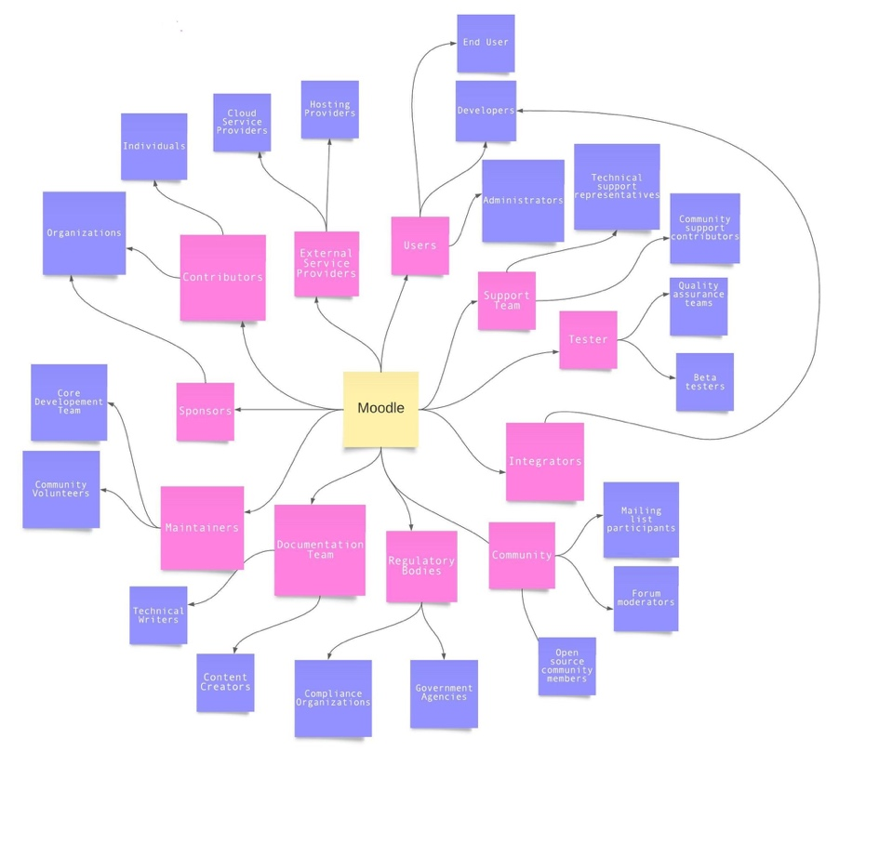

**Fig. 3.1.1** Stakeholder Model (Mind Map)

**1. Users:** Moodle caters to your learning needs by offering a versatile online platform where you can access engaging courses, interactive assessments, and a wealth of educational resources, empowering you to personalize your learning experience and achieve your academic goals.

* **End Users**
* **Developers**
* **Administrators**

**2.** **Support** **Team:** Ensure users receive prompt and effective support, fostering a positive and productive learning environment.

* **Technical** **Support** **Representatives:** Moodle's technical support representatives are highly skilled professionals who offer specialized assistance.
* **Community Support Contributors:** Moodle's community support contributors are dedicated individuals who actively engage with users and share their expertise

**3. Tester:** Testers within Moodle play a crucial role in upholding the platform's reliability and quality. Through meticulous testing and error identification.

1. **Quality Assurance Teams:** Quality assurance teams in Moodle are dedicated groups tasked with conducting thorough testing and validation processes.

* **Beta Testers:** Beta testers in Moodle are enthusiastic volunteers who have the opportunity to explore new features and updates before their official release.

**4. Integrators:** Integrators play a pivotal role in seamlessly integrating external systems and applications within Moodle, facilitating interoperability, and enriching the platform's functionality to deliver an enhanced user experience.

* **Developers:** Moodle developers are proficient experts who utilize the platform's vast range of APIs and flexible architecture to design and tailor creative educational solutions, extend capabilities, and optimize the learning journey for users.

**5. Community:** The thriving community surrounding Moodle cultivates an atmosphere of collaboration, knowledge exchange, and continuous growth, providing valuable support and resources for learners, educators, and administrators.

* **Mailing List Participants:** Active contributors in Moodle's mailing lists actively engage in constructive discussions, share their expertise, and exchange ideas.
* **Forum Moderators:** Forum moderators in Moodle play a pivotal role in facilitating meaningful discussions, maintaining a respectful and productive environment, and offering guidance and assistance to users.
* **Open-Source Community Members:** Members of Moodle's open-source community actively contribute code, plugins, and resources, promoting collaboration and innovation.

**6. Regulatory Bodies:** Regulatory bodies play a vital role in ensuring that Moodle complies with educational standards, privacy regulations, and data protection requirements, safeguarding the interests and security of learners and educational institutions.

* **Compliance Organizations**
* **Government Agencies:**

**7. Documentation Team:** The committed documentation team within Moodle ensures the creation of extensive and user-centric documentation, offering learners, educators, and administrators’ valuable resources and guidance for optimal utilization of the platform.

* **Content Creators**
* **Technical Writers**

**8. Maintainers:** The dedicated maintainers of Moodle ensure the platform's consistent functionality, stability, and security, continuously updating and delivering a dependable learning environment.

* **Core Development Team**
* **Community Volunteers**

**9. Sponsors:** The supportive sponsors of Moodle generously offer financial backing and resources, facilitating the ongoing growth and accessibility of the platform to meet the evolving needs of learners worldwide.

* **Organizations:** Moodle's organizational stakeholders encompass a wide range of educational institutions, businesses, and non-profit organizations.

**10. Contributors:** The committed contributors in Moodle actively contribute their skills, expertise, code contributions, documentation, and support.

* **Organizations**
* **Individuals:** Individual contributors in Moodle encompass a diverse range of educators, developers, administrators, and passionate enthusiasts who actively engage in forums, share their knowledge.

**11. External Service Providers:** External service providers bring tailored solutions and services that seamlessly integrate with Moodle, enhancing its capabilities and addressing the specific requirements of learners and educational institutions.

* **Cloud Service Providers**: Cloud service providers offer scalable hosting infrastructure and resources for Moodle.
* **Hosting Providers**: Hosting providers furnish dependable server infrastructure and technical assistance for Moodle, establishing a secure and stable environment for the platform to operate, guaranteeing uninterrupted access and seamless learning experiences.

**Fig. 3.1.2** Stakeholder Model

# CONTRIBUTIONS ON DELIVERABLE 1

|  |  |
| --- | --- |
| **Team Members** | **Contributions** |
| Pratik Gondaliya | * Create Github Repository * Worked on Problem 1  1. Purpose of Moodle 2. Characteristics of Moodle 3. Salient Software Activities Carried Out in the development of Moodle. |
| Ankur Das | * Worked on Problem 3 * Stackholder model of Moodle  1. UML Class Diagram  * References |
| Nihar Sheth | * Worked on Problem 2 * Context of use for Moodle  1. Users 2. Courses 3. Course Content 4. Activities 5. Mobile Access  * Roles and Responsibilities |
| Bala Sharanya Devarapu | * Worked on Problem 2 * Context of use for Moodle  1. Grading and Assessment 2. Communication and Collaboration 3. Administrative Tools 4. Integration and Extensibility |
| Prabhjot Singh | * Worked on Problem 3 * Stackholder model for Moodle.  1. UML Class Diagram  * Documentation. |

**Table 4.1.1 Contributions on Deliverable 1**

# REFERENCES

1. Miftahur Rohman, Suyono, Agus Wiyono, Farid Baskoro, "Combination of Moodle Online Learning Application (Vilearning UNESA) and Google Classroom to Improve the Quality of Online Learning", 2021 Fourth International Conference on Vocational Education and Electrical Engineering (ICVEE), pp.1-6, 2021.
2. Onjira Sitthisak, Lester Gilbert, Dietrich Albert, "Learning in Moodle using Competence-Based Knowledge Space Theory and IMS QTI", 2013 International Computer Science and Engineering Conference (ICSEC), pp.53-57, 2013.
3. Konstantinos Dimitropoulos, Stylianos Mystakidis, Maria Fragkaki, "Bringing Educational Neuroscience to Distance Learning with Design Thinking : The Design and Development of a Hybrid E-learning Platform for Skillful Training", 2022 7th South-East Europe Design Automation, Computer Engineering, Computer Networks and Social Media Conference (SEEDA-CECNSM), pp.1-6, 2022.
4. S. Kumar, A. K. Gankotiya and K. Dutta, "A comparative study of moodle with other e-learning systems," 2011 3rd International Conference on Electronics Computer Technology, Kanyakumari, India, 2011, pp. 414-418, doi: 10.1109/ICECTECH.2011.5942032.
5. <https://docs.moodle.org/402/en/Features>
6. <https://docs.moodle.org/402/en/History>
7. <https://www.youtube.com/watch?v=3ORsUGVNxGs>

* **Github Repository URL:**

<https://github.com/mrgps1999/SOEN6471_OPENARCH>